
Daxter
Account Data Aggregation and Insights Dashboard

Abstract
This Accountant Data Aggregation and Insights Dashboard addresses core challenges faced by OpenTax in providing a unified, real-time platform for tax compliance by simulating a crucial, Ai driven workflow. OpenTax’s platform consolidates vast amounts of financial and tax data from multiple agent services into a single, intuitive dashboard for accountants.
The objective of Daxter (project) is to implement a miniature, end-to-end system that demonstrates the robust full-stack and Ai-first competencies required for the role. Specifically, the focus on:
- Simulating Data Ingestion from multiple agent-based sources.
- Implementing backend services (like those built with Python/FastAPI) to process, store (SQL/Postgres), and manage this high-frequency, real-time data.
- Integrating AI Agent Orchestration, utilizing principles of multi-agent systems and LLMs for summarizing the ingested data and handling natural language queries.
- Developing a user-friendly frontend (React/Nex.js) dashboard that visualizes the simulated real-time data, offers query capabilities, and includes essential AI observability features.
This practical simulation will effectively showcase proficiency in React/Next.js, Python/FastAPI, SQL/Postgres, and AI agentic workflows, aligning directly with the key requirements for a Full Stack Developer at OpenTax.

Introduction
Daxter Project: Technical Documentation Contents
This document provides the foundational context, architectural overview, and detailed implementation plan for the OpenTax Agent Data Ingestion and AI Dashboard (Daxter) project. It serves as the primary guidance document for development, setup and testing.

Contents
- Project Context and objectives
- Architectural Overview & Stack
- Environment Setup & Installation
- Implementation & Development Workflow
- Testing & Validation Strategy
- Crucial Technical Deliverables

Project Context and Objectives
Field | Value
Project Title | OpenTax Agent Data Ingestion and AI Dashboard (Daxter)
Document Version | 1.0 (Initial Draft)
Target Audience | Development Team, QA Engineers, DevOps Engineers, Stakeholders
Project Goal | Simulate the core OpenTax workflow: Consolidating real-time financial/tax compliance data from multiple simulated agent-based sources, processing it, and presenting it in a unified dashboard with basic AI query and observability features.

Core System Requirements
- Data Ingestion: Simulate streaming data from independent “agents.”
- Data Persistence: Real-time data handling and persistence in PostgreSQL.
- Agent AI Workflow: Orchestrate an AI agent (using LangGraph) for data summarization and natural language query translation.
- User Dashboard: Develop a modern Next.js/React UI for visualization and interaction.

Architectural Overview & Stack
The system employs a modern, decoupled Full-Stack Architecture consisting of the following core components:
Component | Technology | Role
Frontend | React.js / Next.js (TypeScript) | Presentation Tier. Handles UI, visualization, and real-time data display.
Backend / API | Python (FastAPI) | Application Logic Tier. High-performance, asynchronous API for data ingestion and data serving.
AI / Agent Layer | LangGraph, LLM SDKs (e.g., Gemini) | Agent Orchestration. Manages multi-step AI workflows, RAG, and state persistence.
Data Persistence | PostgreSQL / SQL | Data Tier. Transactional storage for ingested data and agent workflow state.
DevOps | Docker / Docker Compose | Defines and runs a reproducible, multi-service environment for development and production.

Presentation Tier (Frontend)
The frontend is built for performance and complex interaction, serving as the user’s unified dashboard.
Component | Role in Architecture
Next.js / React.js (TypeScript) | The core framework, leveraging Next.js for server-side rendering (SSR) or static generation to optimize load times. TypeScript enforces type safety across the UI.
Material UI (MUI) | Provides a robust set of UI components for the dashboard, ensuring a professional, consistent, and user-friendly design.
Redux (State Management) | Manages complex application-level state, such as real-time dashboard data, user session, and the state of ongoing AI agent runs, ensuring predictability and debuggability.
Chat-like Interface (AI Assistant) | A dedicated component allowing accountants to submit natural language queries. This interface streams requests directly to the FastAPI/AI endpoints.
API Endpoints | All user interactions (data refresh, queries) translate into calls to the FastAPI Backend via these endpoints.

Application Logic Tier (Backend & Ai)
This is the control centre for data processing, business logic, and AI orchestration.
Component | Role in Architecture
Python (FastAPI) | The core server and asynchronous API, chosen for its high performance. It handles data ingestion, API rate limiting, and routing requests to the appropriate services.
SQLAlchemy (ORM) | The Object-Relational Mapper (ORM) used by FastAPI to abstract database interactions, making data queries and modifications type-safe and easier to manage with Postgres.
Agent Orchestration (LangGraph) | Manages the complex, multi-step AI workflows. This system orchestrates a sequence of LLM calls, tool use (e.g., database query), and conditional logic to fulfill user requests (summaries/queries).
LLM API (Gemini) | The external Large Language Model service that powers the core intelligence, used by the Agent Orchestration layer for tasks like: 1. Summarizing incoming data; 2. Translating natural language queries into executable SQL; 3. Synthesizing final, insightful answers for the user.

Data Tier
Component | Role in Architecture
PostgreSQL | The primary relational database, storing all structured tax data ingested from external agents, and the persistent state/checkpoints of the AI agent workflows.

Data & Request Flow Walkthrough
This section details the three primary functional flows within the Daxter system, referencing the specific API endpoints.
- Data Ingestion Flow (Simulated Agents)
  - Agent Data (simulated) is sent to the FastAPI backend via the endpoint: /api/data-ingest
  - FastAPI validates and processes the incoming data.
  - SQLAlchemy handles the ORM layer, persistently storing the new tax and financial records in PostgreSQL.
- Dashboard Data Flow (Visualization & Observability)
  - The Next.js Frontend (Dashboard View) simultaneously request two primary data sets:
    - Summary Data: Calls the endpoint /api/summary to retrieve aggregated financial and compliance metrics.
    - Agent Logs/Status: Calls the endpoint /api/agent-logs to populate the observability dashboard with the status and history of recent agent runs.
  - FastAPI executes efficient queries (via SQLAlchemy) against PostgreSQL to fetch the necessary aggregated data and log entries.
  - The data is returned to the frontend, updating the Redux store and rendering the dashboard using Material UI components.
- AI Query Flow (Chat Interface)
  - The user submits a natural language query via the Chat-like Interface.
  - The request is sent to the dedicated AI assistant endpoint: /api/ai-asssistant.
  - FastAPI initializes the Agent Orchestration (LangGraph) workflow.
  - LangGraph uses the LLM API to reason about the query and select a tool (generating a precise SQL query or looking up a log).
  - If a database tool is used, FastAPI/SQLAlchemy executes the generated query against PostgreSQL
  - The result set is passed back to the LLM for final synthesis into a natural language answer.
  - The final, synthesized answer is streamed back through FastAPI to the Next.js Frontend and displayed in the chat interface.

Environment Setup & Installation

General Tooling

VS Code
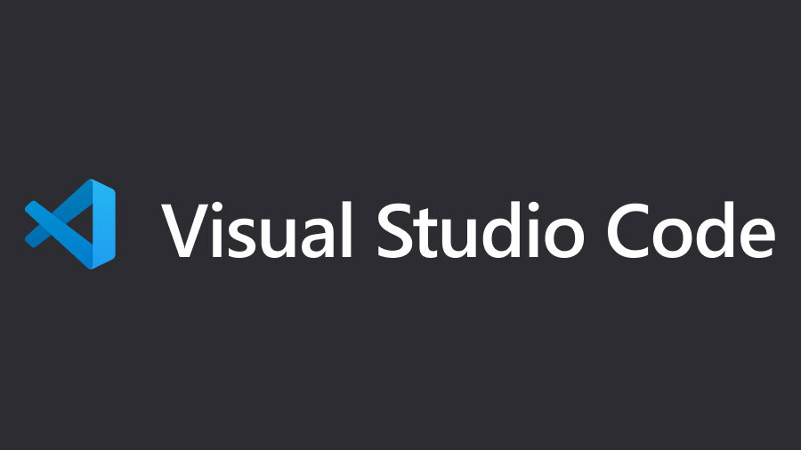
VS Code is a free and lightweight source-code editor from Microsoft for Windows, MacOS, and Linux. It’s used for writing, debugging, and managing code across a wide range of programming languages by providing features like syntax highlighting, intelligent code completion (IntelliSense), and built-in Git support. VS Code is highly customizable through extensions and its popularity stems from its speed, versatility, and user-friendly interface
- Getting Started: https://code.visualstudio.com/docs/getstarted/getting-started
- Installation: https://code.visualstudio.com/

Anaconda

A popular distribution of the Python and R programming languages that is specifically designed for data science, machine learning, and scientific computing. It bundles a large number of pre-installed packages and includes a powerful package and environment manager called Conda Nav to simplify the management of dependencies.
- Getting Started: https://www.anaconda.com/docs/getting-started/getting-started
- Installation: https://www.anaconda.com/docs/getting-started/anaconda/install

Create Virtual Environment
- Enter this in the command line:
- Check if your installation was successful and environment path is synced
“’ conda –version ‘”
- Create new virtual environment for Daxter
‘’’ conda create -n daxter python=3.11 ‘’’
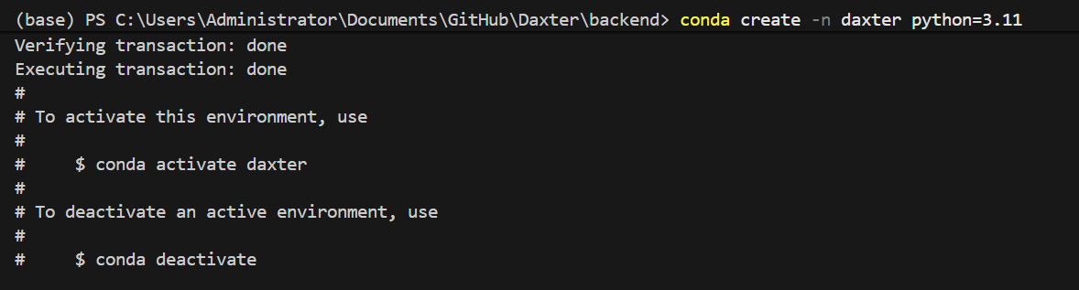

- Check if environment was created successfully
‘’’ conda env list ‘’’
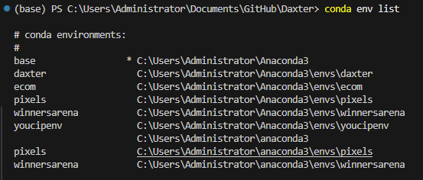
- Switch to Daxter’s virtual environment
‘’’ conda activate daxter ‘’’

Python
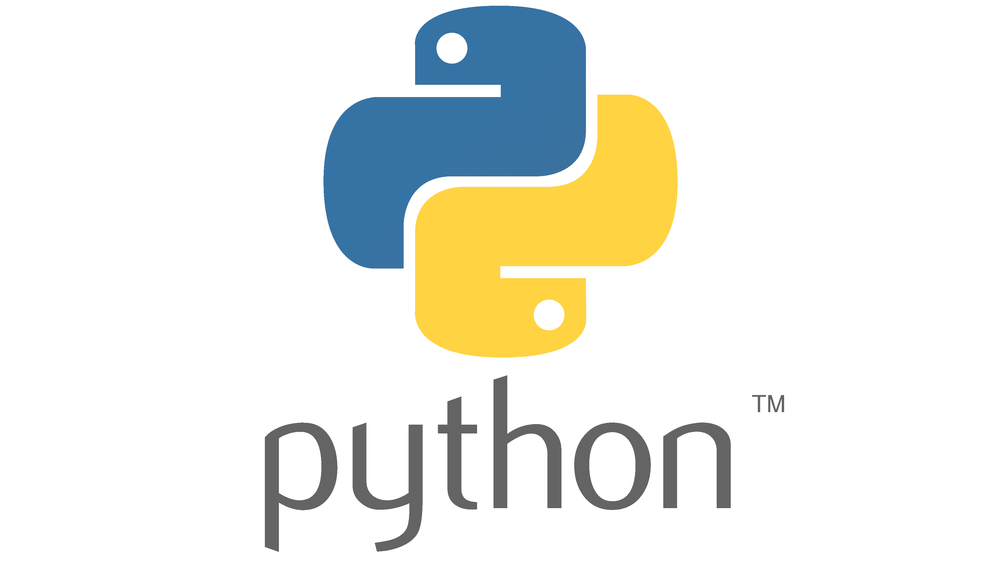
A versatile, high-level, and beginner-friendly programming language used for a wide range of applications like web development, data analysis, automation, and artificial intelligence. It’s easy-to-read syntax allows complex problems to be solved with fewer lines of code, and it can be used cross-platform.
- Getting Started: https://www.python.org/about/gettingstarted/
- Installation: https://www.python.org/downloads/

PIP
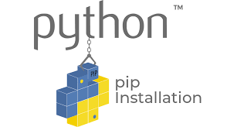
PIP (Pip Installs Packages) is the standard package manager for Pyhton. It is a command-line tool used to install and manage software packages (libraries and dependencies) that are not part of the Python standard library
- Getting started with pip https://pip.pypa.io/en/stable/getting-started/
- Installation: Prebundles with Python Installation

- Navigate to the project root that contains ‘requirements.txt’
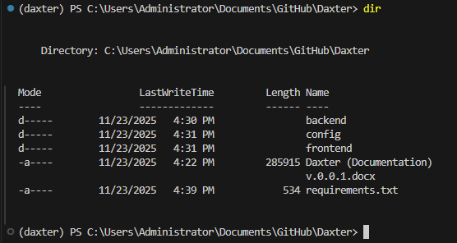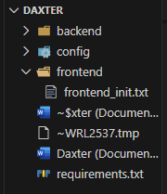
- While ‘daxter’ env is active and you are in the right directory install the requirements file
‘’’ pip install -r requirements.txt ‘’’
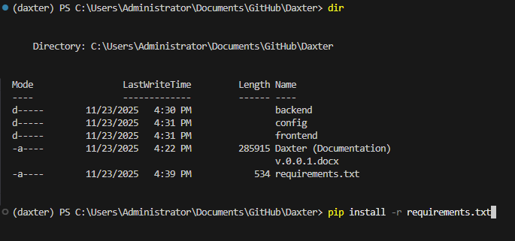

Node js
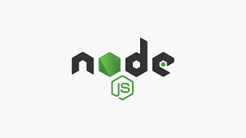
An open-source, cross-platform JavaScript runtime environment that allows developers to execute JavaScript code outside of a web browser. Traditionally, JavaScript was confined to client-side web development within browsers, but Node.js extended its capabilities to server-side and networking applications.
- Getting Started: https://nodejs.org/en/learn/getting-started/introduction-to-nodejs
- Installation: https://nodejs.org/en/download

NPM

A default package manager for the JavaScript runtime Node.js. It includes a command-line interface (CLI) and a vast online registry of millions of open-source packages that developers can use to add functionality to their projects. NPM simplifies development by allowing users to easily install, share, and manage reusable code, which save them from having to write everything from scratch.
- Getting Started: https://docs.npmjs.com/getting-started
- Installation: Pre-bundled with the Node.js installation

Create Frontend Dependencies File (package.json)
Move to the frontend directory and set up the package manifest for Next.js application, which uses React, Type Script, Material UI, and Redux

- Navigate into frontend folder using cmd
‘’’ cd frontend ‘’’

- Initialize Node.js Project
‘’’ npm init -y ‘’’
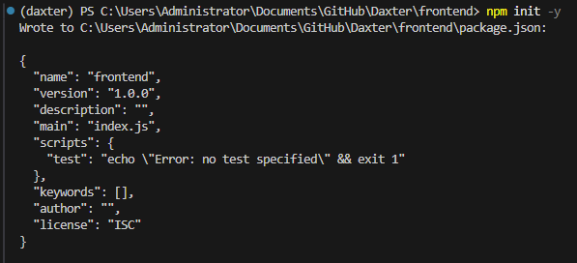
- Define required dependencies based on our frontend stack (Next.js, React, TypeScript, Redux, Material UI)
Initial package.json
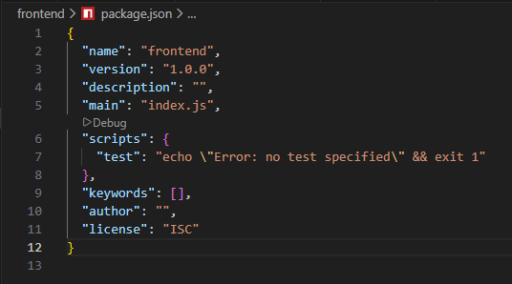

Modified package.json
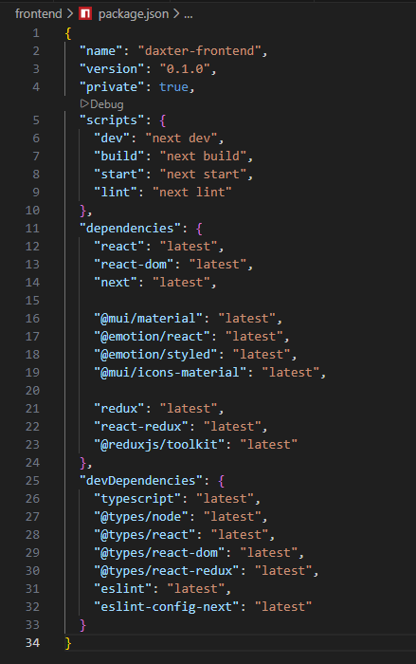
- Install the defined packages:
‘’’ npm install ‘’’

This will create the node_modules folder and the package-lock.json file inside the frontend directory

Docker (Orchestration Layer)
Docker compose will allow us to run all three services – FastAPI, Next.js, and PostgreSQL – with a single command, simulating our production environment.

Define Services
With docker-compose.yml and add the following configuration file (This file defines three interconnected services: db, backend, and frontend.
- Create the Docker Compose File in the root directory of our project
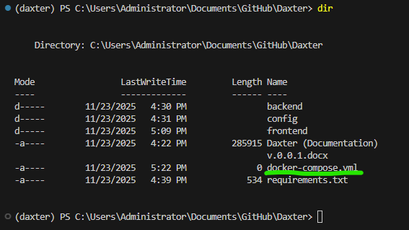

- Add configuration
YAML configuration for our project
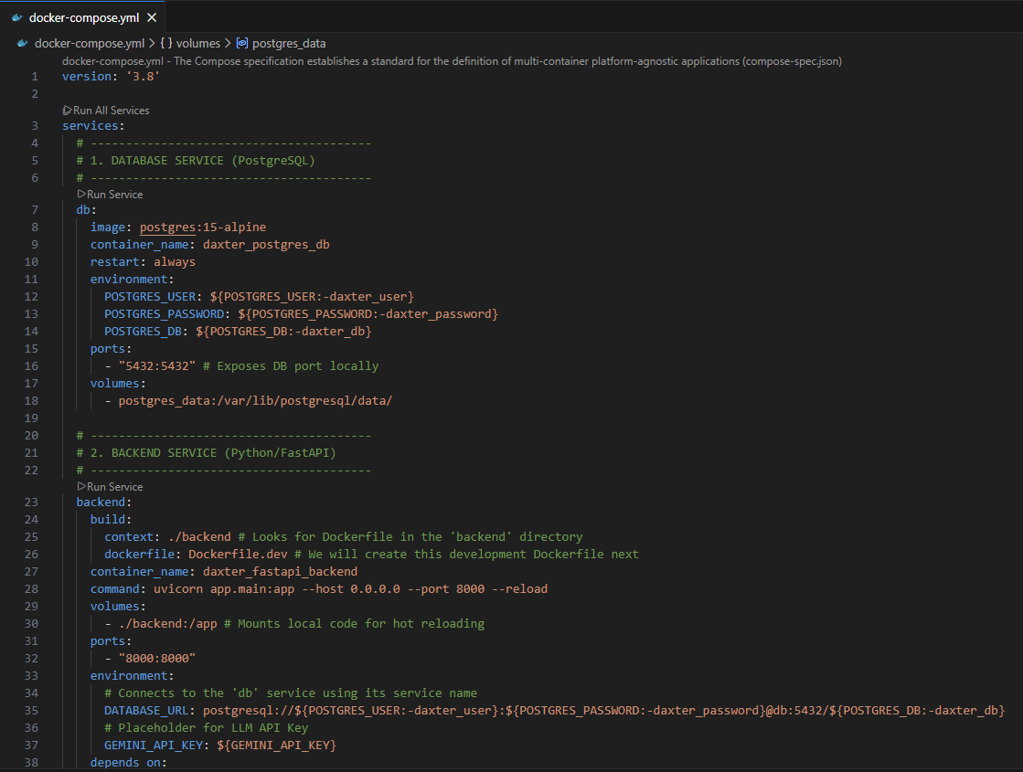
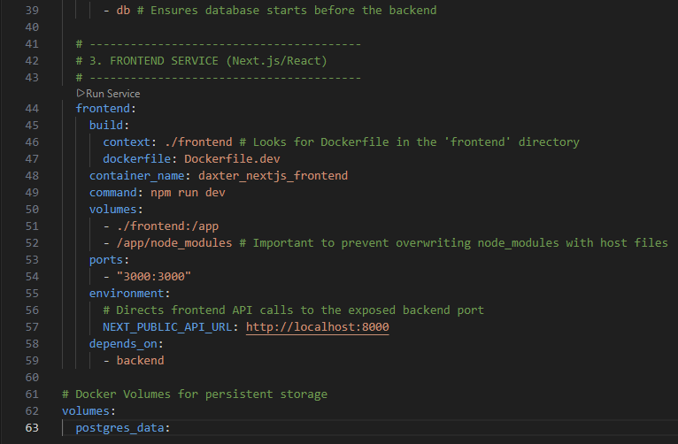

What this configuration does:
- db Service: Pulls the official PostgreSQL 15 image, sets up the database, and uses a volume (postgres_data) to ensure data persists even if the container is stopped or removed.
- Backend Service: Builds a Docker image using the files in the ./backend directory. It exposes port 8000, mounts the local code for live reloading during development, and crucially, sets the DATABASE_URL to connect to the db service.
- Frontend Service: Builds and image from the ./frontend directory, exposes port 3000, and sets the NEXT_PUBLIC_API_URL to point to the backend service.

Create Backend Development Dockerfile
Now let’s create the necessary Dockerfile backend/Dockerfile.dev for FastAPI backend service. This file tells Docker how to build the environment defined in the docker-compose.yml file
- Create the File
Navigate to backend folder:

- Add Dockerfile Content:
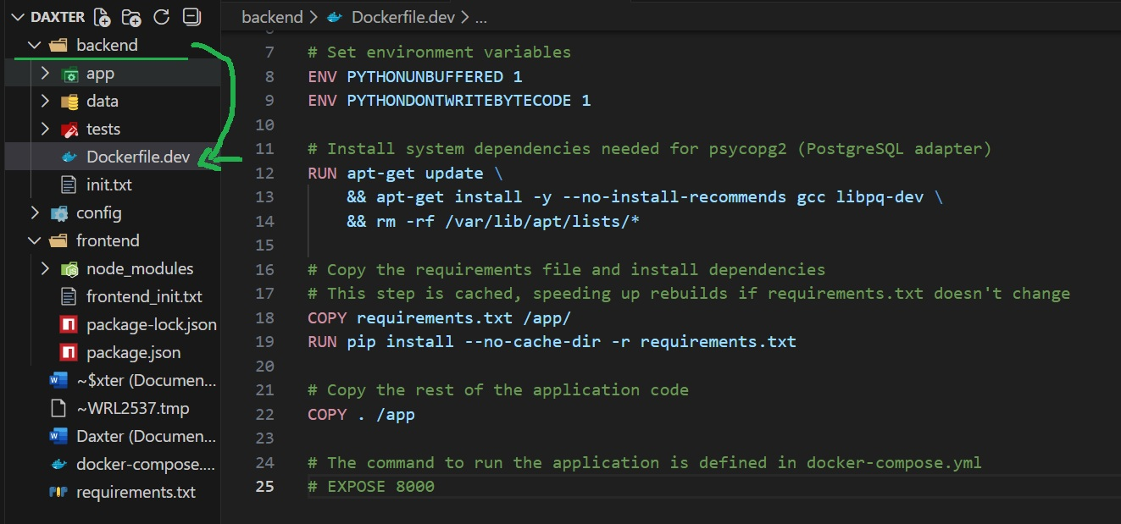

What this Dockerfile does:
- FROM python: 3.11-slim: Uses a lightweight Python base image, matching our Conda environment version.
- RUN apt-get install: Installs essential system libraries (like libpq-dev) needed to compile and install the psycopg2-binary package, which is necessary to connect to PostgreSQL.
- Copy requirements.txt and Run pip install: Installs all our Python dependencies. This is done before copying the rest of the code for better Docker caching.
- COPY. /App: Copies the rest of the local code (the app/ folder, etc.) into the container.

Create Frontend Development Dockerfile
This file tells Docker how to build the isolated environment for our Next.js application, which runs on Node.js
- Navigate into the frontend directory and create Dockerfile.dev

- Add Dockerfile Content

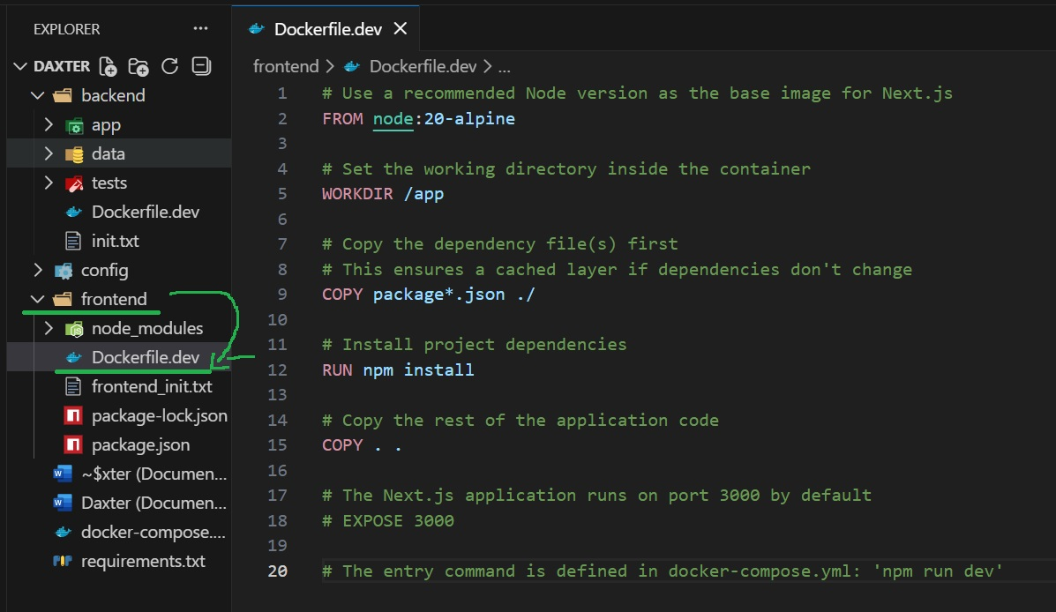

What this Dockerfile does:
- From node: 20-alpine: Uses a lightweight Node.js base image (v20) to run the frontend application.
- WORKDIR /app: Sets the working directory inside the container.
- COPY package*.json ./: Copies the dependency manifest.
- RUN npm install: Installs all React, Next.js, Redux, and Material UI dependencies defined in package.json.
- COPY: Copies the rest of the source code (which we will create next, like pages/ , components/ , etc.) into the container.

Redux
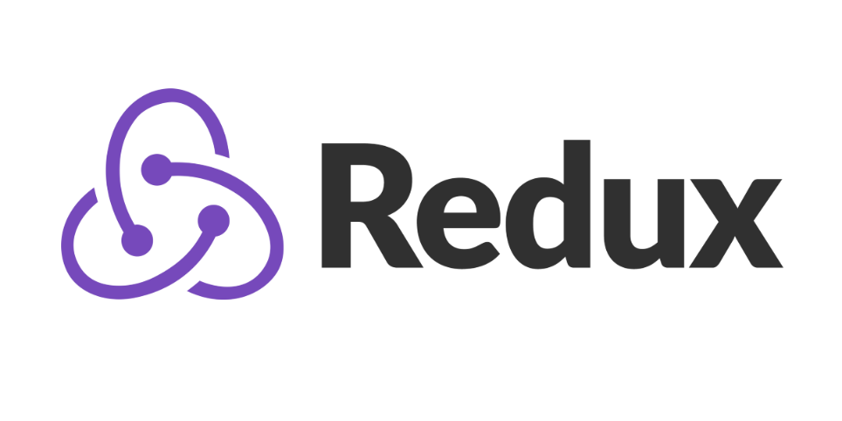
An open-source JavaScript library for managing an application’s state in a predictable way, especially in complex apps built with libraries like React. It centralizes state and logic, making applications more consistent, debuggable, and testable by guiding you towards a strict data flow pattern. It’s core components are a single store to hold the state, actions to describe what happened, and reducers (pure functions) to update the state immutably.
- Getting started: https://redux.js.org/introduction/getting-started
- Installation: https://redux.js.org/introduction/installation

FastAPI

FastAPI is a modern, high-performance web framework for building APIs with Python. It is designed for ease of use, speed of development, and robust performance, making it a popular choice for creating web services and microservices.
- Getting started: https://fastapi.tiangolo.com/tutorial/first-steps/

PostgreSQL
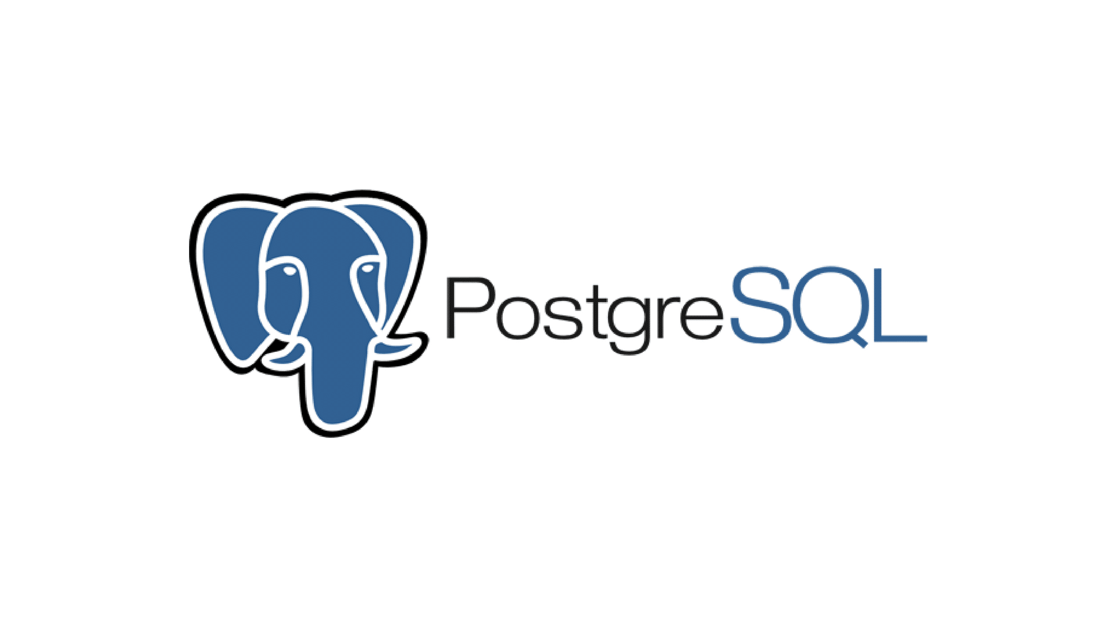
A powerful, open-source, object-relational database management system (ORDBMS) know for its reliability, flexibility, and standards compliance. It is used to store and retrieve data for a wide range of applications, from small single-machine programs to large, high-traffic systems. PostgreSQL supports both relational (SQL) and non-relational (JSON) data, and its extensive feature set makes it popular with developers and administrators.
- Getting Started: https://www.postgresql.org/docs/current/tutorial-start.html
- Installation: https://www.postgresql.org/download/

Git version control
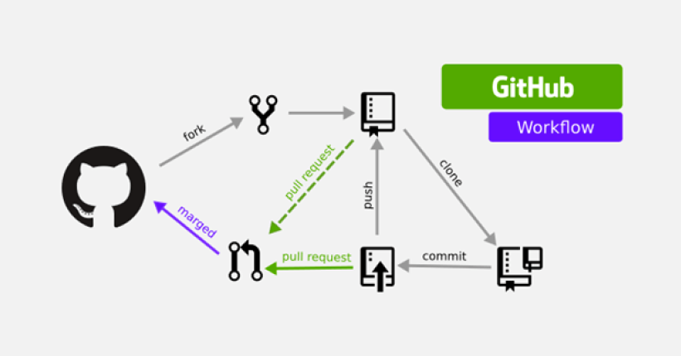
Git is a distributed version control system (DVCS) that tracks changes in files, typically source code, and helps manage project history. It enables multiple developers to collaborate on the same project efficiently without overwriting each other’s work.
- Getting started: https://git-scm.com/book/ms/v2/Getting-Started-About-Version-Control
- Installation: https://git-scm.com/install/windows
- Install Git Large File Storage (LFS)

Implementation & Development Workflow

Version Control (Git & PR Workflow)
- Repository: Project initialized with Git and hosted on a collaborative platform.
- Branching Strategy: Use the Feature Branch Workflow (main branch for production, feature branches for development).
- Code Quality: All features require a successful automated test suite run and an approved Pull Request (PR) before merging.

Local Development Practices
- Local Services: The PostgreSQL Docker container must be running first. The Backend (FastAPI/Uvicorn) and Frontend (Next.js dev server) will run from the host machine within their respective isolated environments.
- Isolation: Development will occur within the dedicated Conda and Node environments.
- Debugging: Utilize VS Code's integrated debugging for both Python (backend) and JavaScript (frontend) codebases.

Phase 1

Successfully setup the structure, defined dependencies, and configured Docker Compose and both Dockerfiles (front & back). Now, the initial code to make services runnable and test our setup

Backend Entry Point
To ensure FastAPI service can start and connect to the database

Create FastAPI Entry Point
(backend/app/main.py)
  - Navigate into the application source directory (backend/app) and create the main.py file
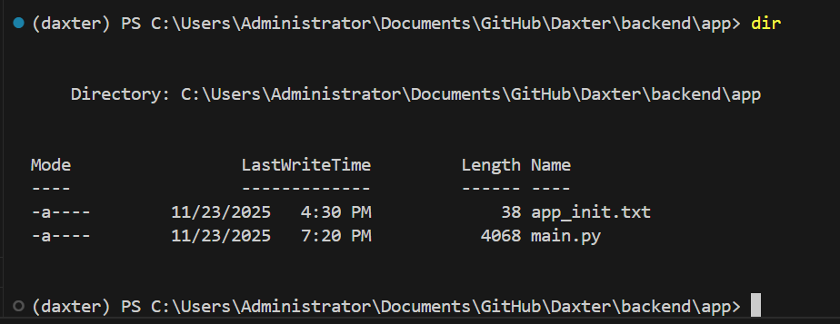
  - Add initial FastAPI Code
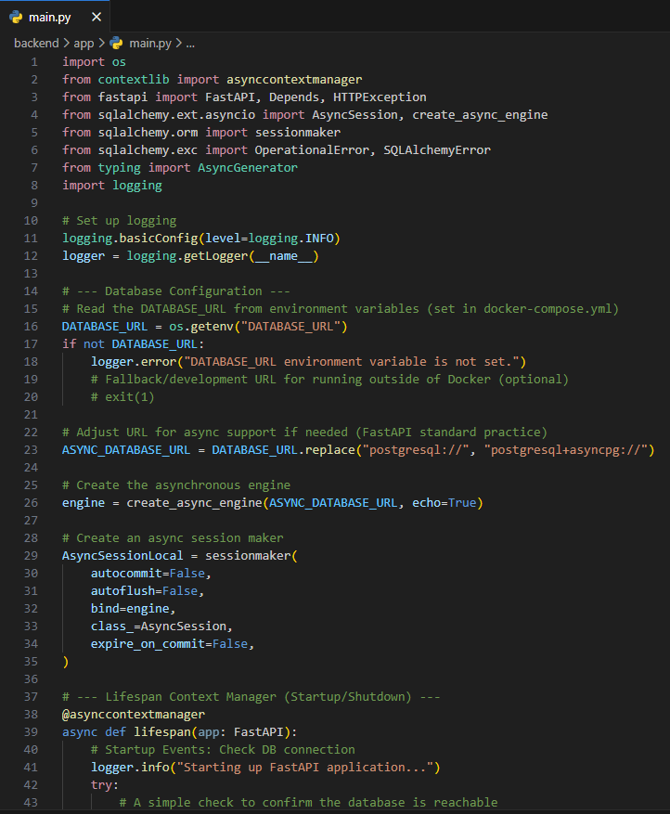
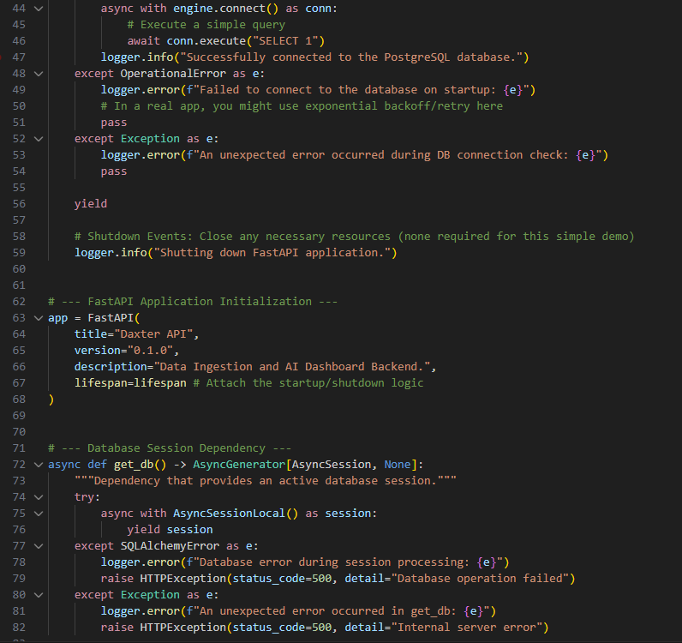
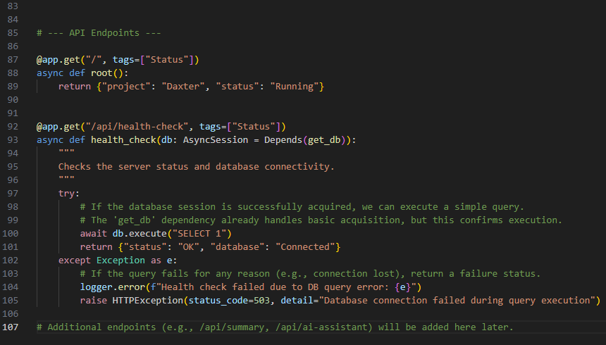
  - Test the Full Stack
Test if entire containerized environment starts correctly:
    - Navigate to the project root directory
    - Create a in the project root .env file to house all confidential passwords and other credentials
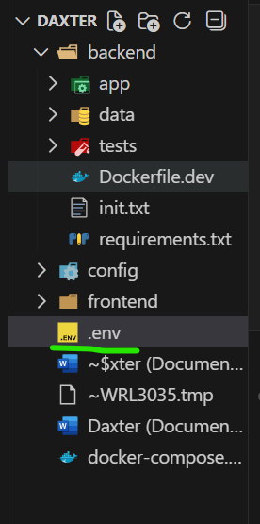
    - Visit Gemini studio and create an API Key. Past the API key in the .env file

    - Open Docker Desktop
    - Run the following command
  - Expected Outcomes
    - The PostgreSQL db container will start up and listen on port 5432
    - The FastAPI backend container will start, successfully import asyncpg, and the logs should now display:
‘’’ Successfully connected to the PostgreSQL database.
    - The Frontend daxter_nextjs_frontend will still exit with an error. This is expected because we haven’t written the Next.js code yet

SQLAlchemy

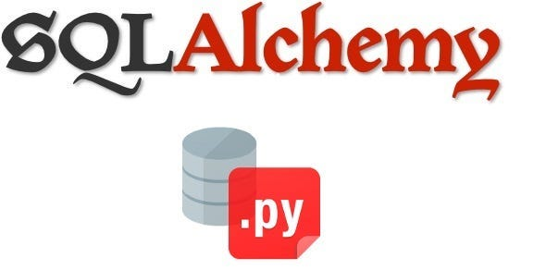

SQLAlchemy is an open-source SQL toolkit and Object-Relational Mapper (ORM) for the Python programming language. It is designed to provide application developers with the full power and flexibility of SQL while using a Pythonic domain language.
Getting started: https://docs.sqlalchemy.org/en/20/orm/quickstart.html
Installation: pip install sqlalchemy

Main file (main.py)
The entry point for executing Daxter. Setup main file for FastAPI application with an asynchronous PostgreSQL connection using SQLAlchemy.

Database File (database.py)
Centralises the ORM setup, including the base class, session management for database interactions, and alembic migrations. Contains necessary code to connect to PostgreSQL database, execute queries, and perform operation like inserting, updating, or retrieving data.

Alembic

A professional tool for managing database schema changes (migrations), ensuring that changes to SQLAlchemy models are reliably applied to PostgreSQL database across development and production environments.
- Navigate to Daxter/backend/ initialize Alembic Project

- If not created, create alembic.ini in backend/alembic/
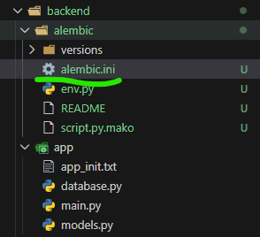
This alembic.ini file is the main configuration file for the Alembic database migration tool. It acts as the central control panel, defining where Alembic finds its scripts, how it connects to the database, and which logging levels to use.

Script and Path Location ([alembic] section)

Script location: Tells Alembic where to find the migration environment files (env.py) and where to store the generated migration scripts (versions/). For us, this is set to the alembic folder inside the backend directory.

Prepend_sys_path = . : Crucial for Python imports. This ensures the current directory (backend/) is added to Python's path, allowing the alembic/env.py script to successfully run from app import models and find our application's data schemas.

File_template: Defines the naming convention for new migration files. We customized it to include a date and revision ID (e.g., YYYYMMDD_[rev]_[slug].py) for easier organization.

Database Connection (Dynamic via env.py)
Sqlalchemy.url: This is where you would normally hardcode a database connection string. In our setup, we intentionally leave this line commented out. Instead, we configure the connection dynamically inside alembic/env.py by reading the DATABASE_URL from the environment variables (. env/Docker Compose). This makes the configuration environment-aware and secure.

Logging Configuration ([loggers], [handlers])
This section controls how much output Alembic generates during execution. We configured it to show INFO level for Alembic itself (so you see when a migration runs) and WARN for SQLAlchemy (to suppress excessive engine logs).
- Re

Models file (models.py)
Define the structure of a the database by using Python classes to represent database tables, with each class attribute corresponding to a table’s column. Allows interactions with database using Python objects instead of raw SQL, and provides the foundation for CRUD functions.

Define Pydantic Schemas
Pydantic schemas, often referred to as Pydantic models, are Python classes that define the structure, types, and validation rules for data. They are a core component of the Pydantic library, a data validation and settings management tool that leverages Python’s type hints. Pydantic models are used by FastAPI to validate incoming JSON data (for POST requests) and structure outgoing JSON data (for responses).
- Getting Started: https://docs.pydantic.dev/dev/
- Installation: https://docs.pydantic.dev/1.10/install/

/api/data-ingest
Implement POST Endpoint. This endpoint receives the data, validates it using AccountantDataCreate , converts it into the SQLAlchemy model, and commits it to the database

/api/summary
Implement GET Endpoint. This endpoint fetches aggregated data required for the dashboard

Testing & Validation Strategy
This project will employ a multi-layered testing strategy to ensure reliability, especially for the complex agent logic
Test Type | Target Layer | Tooling | Focus
Unit Testing | Backend Python Logic, Agent Nodes, Frontend Components | Pytest, Jest / RTL/ | Verifies individual functions and components are correct.
Integration Testing | FastAPI Endpoints, Database ORM | Postman, Pytest TestClient | Verifies data flow and communication between services (API calls, DB persistence).
End-to-End (E2E) Testing | Full Stack Workflow (Docker) | Playwright, Cypress, or Selenium | Simulates full user journeys in the Dockerized environment to confirm deployment readiness.

Crucial Technical Deliverables

- System Architecture Diagram: A visual representation of the component flow.
- API Specification: Detailed documentation of all endpoints (via FastAPI’s OpenAPI/Swagger UI).
- Database Schema (ERD): Entity-Relationship Diagram detailing all data models
- Observability & Monitoring Plan: Strategy for logging agent runs (LangSmith) and application health.
- Security & Deployment Plan: Outline of authentication, secrets management, and container deployment steps.

